OOP Homework Six

Teacher: Ching-Shun Lin

Content
Problem 1 . . . . . . . . . . .2~10

一、 Account class . . . . . . . . . . . . .. . . . . . . . . . . . . . . . . . . . . . . . . . .2
二、 Saving account . . . . . . . . . . . . . . . . . . . . . . . . . . . . . . . . . . . . . .3
三、 Total program and notes . . . . . . . . . . . . . . . . . . . . . . . . . . . . . .4
四、 Running result . . . . . . . . . . . . . . . . . . . . . . . . . . . . . . . . . . . . . .8

Problem 2 . . . . . . . . . . .11~22

一、 Account class . . . . . . . . . . . . . . . . . . . . . . . . . . . . . . . . . . . . . . .11
二、 Saving account . . . . . . . . . . . . . . . . . . . . . . . . . . . . . . . . . . . . . .11
三、 Total program and notes . . . . . . . . . . . . . . . . . . . . . . . . . . . . . .12
四、 Running result . . . . . . . . . . . . . . . . . . . . . . . . . . . . . . . . . . . . . .20
Problem One

一、Account class：
（一）Account class：

Account class member include balance.
And member functions include initial, credit, debit and get balance.

class account
{
private:
double balance;
public:
account();
void credit(double);
short debit(double);
double get_balance();
};

（二）Account class member function：

1、Initial member function：
account::account()
{
balance = 0.0;
}

2、Save money member function：
void account::credit(double money)
{
balance = balance + money;
}

3、Get money member function：
short account::debit(double money)
{
if(balance < money)
{
cout << "Debit amount exceeded account balance.";
return 0;
}
else
{
balance = balance - money;
return 1;
}
}

4、Return balance member function：
double account::get_balance()
{
return balance;
}

二、Saving account class that inherit the functionality of account class：
（一）Saving account class：

Saving account inherit all the member and function of account class
Saving account class member include interest rate.
And member function include initial, change interest rate, print interest rate and calculate interest.

class saving_account:public account
{
private:
double interest_rate;
public:
saving_account();
void change_interest_rate(double);
void print_interest_rate();
double calculate_interest();
};

（二）Saving account class member function：

1、Initial member function：
saving_account::saving_account()
{
interest_rate = 0;
}

2、Change interest rate member function：
void saving_account::change_interest_rate(double rate)
{
interest_rate = rate;
}

3、Print out interest rate member function：
void saving_account::print_interest_rate()
{
cout << "Now interest rate is " << interest_rate << " ℅";
}

4、Calculate interest member function：
double saving_account::calculate_interest()
{
double interest;
interest = (get_balance()) * interest_rate / 100;
credit(interest);
return interest;
}

三、Total program and notes：
#include<iostream>
#include <conio.h>
//Using cin, cout and endl directive.
using std::cin;
using std::cout;
using std::endl;
/*---------------------------------*/
/*----------Class account----------*/
/*---------------------------------*/
class account
{
//Private member of account.
private:
//One data member of type double to represent the account balance.
double balance;
//Public member function of account.
public:
//Initial class member function, let magnitude of balance is 0.
account();
//This member function can save money to balance here.
void credit(double);
//This member function can get money from balance here.
short debit(double);
//This member function can return magnitude of balance.
double get_balance();
};
//Initial account class member function.
account::account()
{
balance = 0.0; //Magnitude is 0.
}
//Credit of account member function.
void account::credit(double money)
{
balance = balance + money; //Add to balance.
}
//Debit of account member function.
short account::debit(double money)
{
//Ensure that the debit amount does not exceed the balance.
if(balance < money)
{
cout << "Debit amount exceeded account balance.";
return 0; //If does not, return 0.
}
else
{
balance = balance - money; //If does, balance minus magnitude of money.
return 1; //If does, return 1.
}
}
//Get balance of account member function.
double account::get_balance()
{
return balance; //Return magnitude of balance.
}
/*----------------------------------------*/
/*----------Class saving_account----------*/
/*----------------------------------------*/
class saving_account:public account
{
//Private member of account.
private:
//Data member of type double indicating the interest rate.
double interest_rate;
//Public member function of account.
public:
//Initial class member function, let magnitude of interest rate is 0.
saving_account();
//This member function can change interest rate here.
void change_interest_rate(double);
//This member function can print out interest rate here.
void print_interest_rate();
//This member function can calculate interest and add to balance of account class.
double calculate_interest();
};
//Initial saving account class member function.
saving_account::saving_account()
{
interest_rate = 0; //Magnitude is 0.
}
//Change interest rate member function.
void saving_account::change_interest_rate(double rate)
{
interest_rate = rate; //Change interest rate.
}
//Print interest ratemember function.
void saving_account::print_interest_rate()
{
cout << "Now interest rate is " << interest_rate << " ℅"; //Print out interest rate.
}
//Calculate interest member function.
double saving_account::calculate_interest()
{
double interest; //Interest register.
interest = (get_balance()) * interest_rate / 100; //Calculate now interest,
credit(interest); //and add to balance of account class.
return interest; //Final, return interest.
}
/*-------------------------------*/
/*---------Main program----------*/
/*-------------------------------*/
int main()
{
cout << "\n---------------∮This program is-★-B9502028-★-陳敬翔-create∮---------------\n";
//Declare a person account.
saving_account person;
//Key register.
char key;
//Money or interest or interest rate register.
double number_register;
//Infinite loop.
while(1)
{
//print out operation instructions.
cout << "\nUsers operate：" << endl
<< "（1）Save money."
<< "（2）Get money."
<< "（3）Amount of balance." << endl
<< "Bank operates：" << endl
<< "（4）Settle account in interest rate."
<< "（5）Alter the interest rate." << endl
<< "Else operates：" << endl
<< "（6）Exit system." << endl
<< "--------------------" << endl
<< "You want to... ";
//Get the key from keyboard, to select mode.
do
{
key = getch();
}
while((key != '1') && (key != '2') && (key != '3') && (key != '4') && (key != '5') && (key != '6'));
//Mode one, save money.
if(key == '1')
{
cout << "save money！\nHow much？→＄";
cin >> number_register;
person. credit(number_register);
cout << "You already save ＄" << number_register << "¯ to your account！";
}
//Mode two, get money.
else if(key == '2')
{
cout << "get money！\nHow much？→＄";
cin >> number_register;
if(person.debit(number_register))
{
cout << "You already get ＄" << number_register << "¯ to your account！";
}
}
//Mode three, print out amount of balance.
else if(key == '3')
{
cout << "know amount of balance！\n";
number_register = person.get_balance();
cout << "＄" << number_register << "¯ still left！\n";
person. print_interest_rate();
}
//Mode four, settle account in interest rate.
else if(key == '4')
{
cout << "settle account in interest rate！\n";
person. print_interest_rate();
cout << "\nYour account can get ＄" << person.calculate_interest() << "¯ interest！";
}
//Mode five, alter the interest rate.
else if(key == '5')
{
cout << "alter the interest rate！\n";
person.print_interest_rate();
cout << "\nSir, do you want to change how much interest rate？→";
cin >> number_register;
person. change_interest_rate(number_register);
person. print_interest_rate();
}
//Mode six, exit this system.
else
{
cout << "\n\nPress the wanton key to exit！";
getch();
break;
}
getch();
cout << "\n\n----------------------------------------";
}
return 0;
}

四、Running result：

（一） Initial of Balance and interest rate are zero.
When user selects three, he can observe magnitude of then.
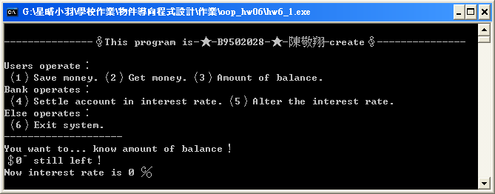

（二） At first, bank select five to alter the interest rate to become five percent.
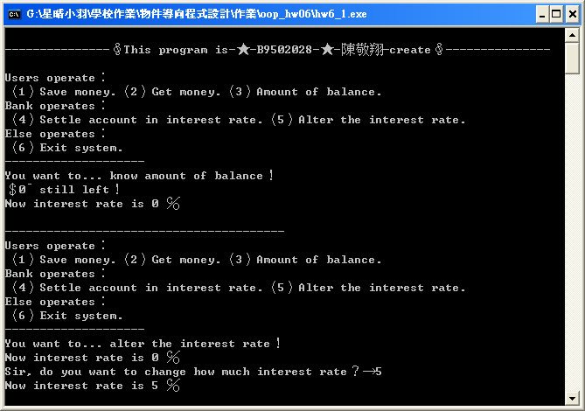

（三） And user want to save two thousand dollars to this account.
So he have to select one, then save money.
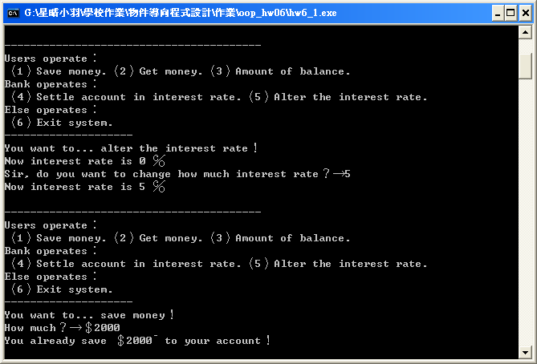
（四） User can select three to observe his account have already saved two thousand dollars.
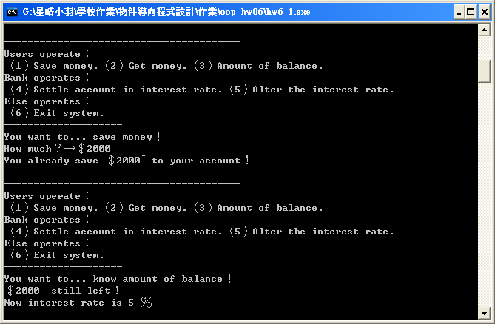

（五） Through bank select four to settle account in interest rate, user can get interest one hundred dollars.
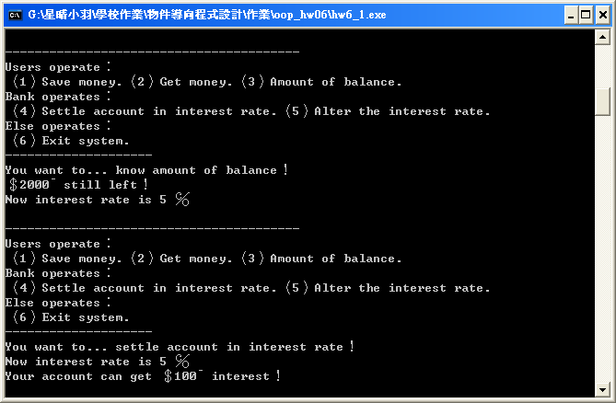

（六） User can select three to observe balance have already added one hundred dollars.
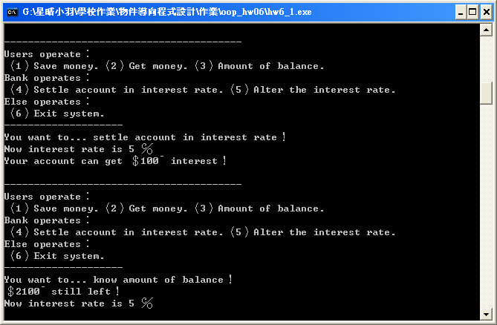
（七） Select two user can get money he have.
First user gets five hundred dollars.
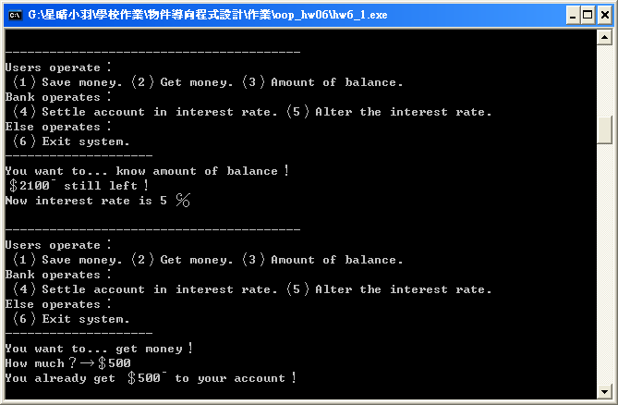

（八） User can select three to observe his account have already decrease five hundred dollars.
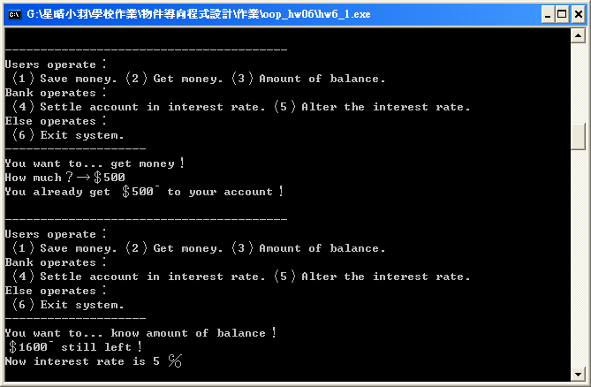

（九） If user want to get three thousand dollars, it will appear error!
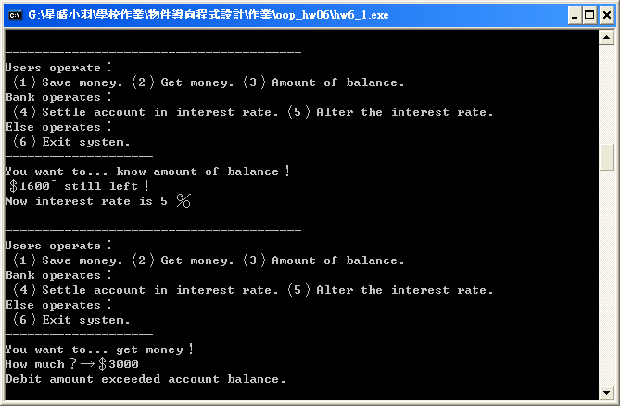
Problem Two

一、Account class：

（一）Account class：

Use the Account class in the previous question.
Member functions become virtual functions.
Content of member functions do not change.

class account
{
private:
double balance;
public:
account();
virtual void credit(double);
virtual short debit(double);
virtual double get_balance();
};

二、Saving account class one and two that use virtual inherit the account class：

（一）Saving account one：

class saving_account_1:virtual public account
{
private:
double interest_rate;
public:
saving_account_1();
void change_interest_rate(double);
void print_interest_rate();
double calculate_interest();
};

（二）Saving account two：

class saving_account_2:virtual public account
{
private:
double interest_rate;
public:
saving_account_2();
void change_interest_rate(double);
void print_interest_rate();
double calculate_interest();
};

三、Total program and notes：

#include<iostream>
#include <conio.h>
using std::cin;
using std::cout;
using std::endl;
/*---------------------------------*/
/*----------Class account----------*/
/*---------------------------------*/
class account
{
//Private member of account.
private:
//One data member of type double to represent the account balance.
double balance;
//Public member function of account.
public:
//Initial class member function, let magnitude of balance is 0.
account();
//Declare three virtual function.
//This credit member function can save money to balance here.
virtual void credit(double);
//This debit member function can get money from balance here.
virtual short debit(double);
//This get_balance member function can return magnitude of balance.
virtual double get_balance();
};
//Initial account class member function.
account::account()
{
balance = 0.0; //Magnitude is 0.
}
//Credit of account member function.
void account::credit(double money)
{
balance = balance + money; //Add to balance.
}
//Debit of account member function.
short account::debit(double money)
{
//Ensure that the debit amount does not exceed the balance.
if(balance < money)
{
cout << "Debit amount exceeded account balance.";
return 0; //If does not, return 0.
}
else
{
balance = balance - money; //If does, balance minus magnitude of money.
return 1; //If does, return 1.
}
}
//Get_balance of account member function.
double account::get_balance()
{
return balance; //Return magnitude of balance.
}
/*------------------------------------------*/
/*----------Class saving_account_1----------*/
/*------------------------------------------*/
//Use virtual inherit.
class saving_account_1:virtual public account
{
//Private member of account.
private:
//Data member of type double indicating the interest rate.
double interest_rate;
//Public member function of account.
public:
//Initial class member function, let magnitude of interest rate is 0.
saving_account_1();
//This member function can change interest rate here.
void change_interest_rate(double);
//This member function can print out interest rate here.
void print_interest_rate();
//This member function can calculate interest and add to balance of account class.
double calculate_interest();
};
//Initial saving account class member function.
saving_account_1::saving_account_1()
{
interest_rate = 0; //Magnitude is 0.
}
//Change interest rate member function.
void saving_account_1::change_interest_rate(double rate)
{
interest_rate = rate; //Change interest rate.
}
//Print interest ratemember function.
void saving_account_1::print_interest_rate()
{
cout << "Now interest rate is " << interest_rate << " ℅"; //Print out interest rate.
}
//Calculate interest member function.
double saving_account_1::calculate_interest()
{
double interest; //Interest register.
interest = (get_balance()) * interest_rate / 100; //Calculate now interest,
credit(interest); //and add to balance of account class.
return interest; //Final, return interest.
}
/*------------------------------------------*/
/*----------Class saving_account_2----------*/
/*------------------------------------------*/
//Use virtual inherit.
class saving_account_2:virtual public account
{
//Private member of account.
private:
//Data member of type double indicating the interest rate.
double interest_rate;
//Public member function of account.
public:
//Initial class member function, let magnitude of interest rate is 0.
saving_account_2();
//This member function can change interest rate here.
void change_interest_rate(double);
//This member function can print out interest rate here.
void print_interest_rate();
//This member function can calculate interest and add to balance of account class.
double calculate_interest();
};
//Initial saving account class member function.
saving_account_2::saving_account_2()
{
interest_rate = 0; //Magnitude is 0.
}
//Change interest rate member function.
void saving_account_2::change_interest_rate(double rate)
{
interest_rate = rate; //Change interest rate.
}
//Print interest ratemember function.
void saving_account_2::print_interest_rate()
{
cout << "Now interest rate is " << interest_rate << " ℅"; //Print out interest rate.
}
//Calculate interest member function.
double saving_account_2::calculate_interest()
{
double interest; //Interest register.
interest = (get_balance()) * interest_rate / 100; //Calculate now interest,
credit(interest); //and add to balance of account class.
return interest; //Final, return interest.
}
/*-------------------------------*/
/*---------Main program----------*/
/*-------------------------------*/
int main()
{
cout << "\n---------------∮This program is-★-B9502028-★-陳敬翔-create∮---------------\n\n";
//Declare two person account.
saving_account_1 person_1;
saving_account_2 person_2;
//Declare two father class pointers to assign.
account *person[2]={&person_1, &person_2};
//Key register.
char key;
//Which ones account pointer.
short who;
//Money or interest or interest rate register.
double number_register;
cout << "First you want to operate which ones account？" << endl
<< "（1）Person one.（2）Person two." << endl;
//Get the key from keyboard, to determine which person first.
do
{
key = getch();
}
while((key != '1') && (key != '2'));
if(key == '1')
{
who = 0;
}
else
{
who = 1;
}
cout << "\n--------------------" << ((who == 0) ? "Person one account" : "Person two account") << "--------------------";
//Infinite loop.
while(1)
{
cout << "\nUsers operate：" << endl
<< "（1）Save money."
<< "（2）Get money."
<< "（3）Amount of balance." << endl
<< "Bank operates：" << endl
<< "（4）Settle account in interest rate."
<< "（5）Alter the interest rate." << endl
<< "Else operates：" << endl
<< "（6）Change user.（7）Exit system." << endl
<< "--------------------" << endl
<< "You want to... ";
//Get the key from keyboard, to select mode.
do
{
key = getch();
}
while((key!='1')&&(key!='2')&&(key!='3')&&(key!='4')&&(key!='5')&&(key!='6')&&(key!='7'));
switch(key)
{
//Mode one, save money.
case '1':
cout << "save money！\nHow much？→＄";
cin >> number_register;
if(who==0)
{
person[who]->credit(number_register);
}
else
{
person[who]->credit(number_register);
}
cout << "You already save ＄" << number_register << "¯ to your account！";
break;
//Mode two, get money.
case '2':
cout << "get money！\nHow much？→＄";
cin >> number_register;
if(who==0)
{
if(person[who]->debit(number_register))
{
cout << "You already get ＄" << number_register << "¯ to your account！";
}
}
else
{
if(person[who]->debit(number_register))
{
cout << "You already get ＄" << number_register << "¯ to your account！";
}
}
break;
//Mode three, print out amount of balance.
case '3':
cout << "know amount of balance！\n";
if(who==0)
{
number_register = person[who]->get_balance();
}
else
{
number_register = person[who]->get_balance();
}
cout << "＄" << number_register << "¯ still left！\n";
if(who==0)
{
person_1.print_interest_rate();
}
else
{
person_2.print_interest_rate();
}
break;
//Mode four, settle account in interest rate.
case '4':
cout << "settle account in interest rate！\n";
if(who==0)
{
person_1.print_interest_rate();
}
else
{
person_2.print_interest_rate();
}
cout << "\nYour account can get ＄"
<< ((who == 0) ? (person_1.calculate_interest()) : (person_2.calculate_interest()))
<< "¯ interest！";
break;
//Mode five, alter the interest rate.
case '5':
cout << "alter the interest rate！\n";
if(who==0)
{
person_1.print_interest_rate();
}
else
{
person_2.print_interest_rate();
}
cout << "\nSir, do you want to change how much interest rate？→";
cin >> number_register;
if(who==0)
{
person_1.change_interest_rate(number_register);
person_1.print_interest_rate();
}
else
{
person_2.change_interest_rate(number_register);
person_2.print_interest_rate();
}
break;
//Mode six, Change user.
case '6':
cout << "Change user！";
if(who==0)
{
who=1;
}
else
{
who=0;
}
break;
//Mode seven, exit this system.
case '7':
cout << "\n\nPress the wanton key to exit！";
getch();
break;
default:
cout << "\n\nSystem error！";
getch();
break;
}
if(key=='7')
{
break;
}
getch();
cout << "\n\n--------------------" << ((who == 0) ? "Person one account" : "Person two account") << "--------------------";
}
return 0;
}

四、Running result：

（一） Initial of Balance and interest rate are zero.
All user can selects three, they can observe magnitude of then.
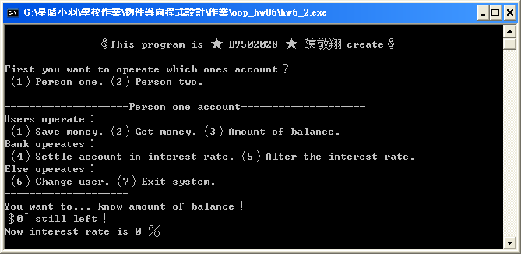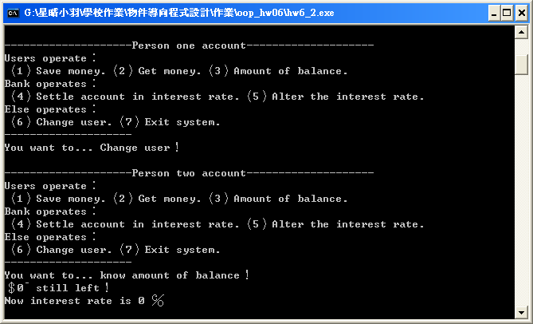

（二） At first, bank select five to alter the account one interest rate to become one percent.
And alter the account two interest rate to become ten percent.
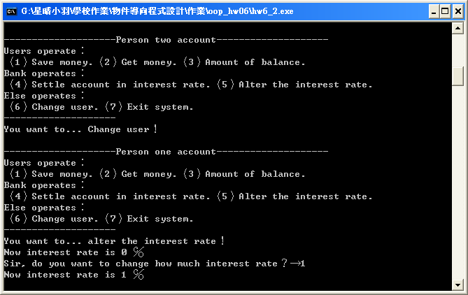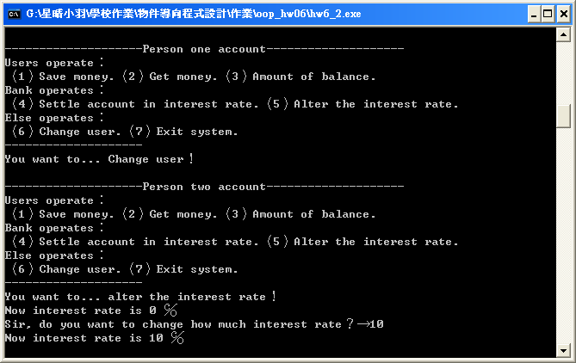

（三） And user one want to save five thousand dollars to his account.
User two want to save one thousand dollars to her account
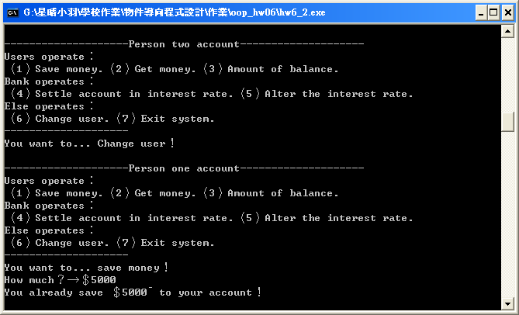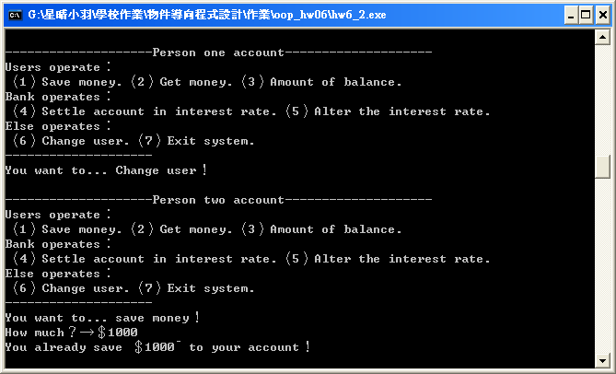

（四） All User can select three to observe their account have already saved how money.
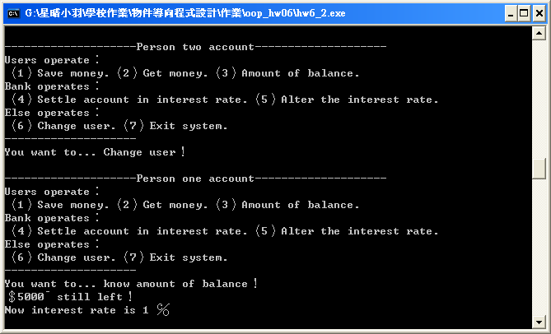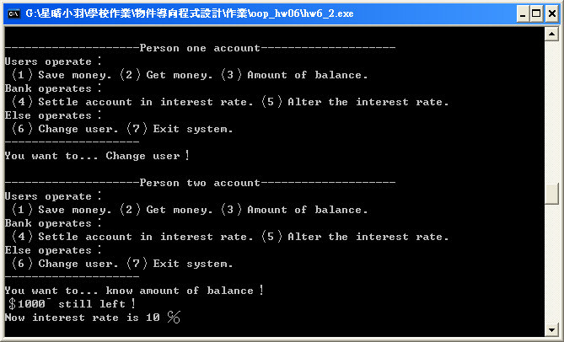

（五） Through bank select four to settle accounts in interest rate.
User one can get interest fifty dollars.
User two can get interest one hundred dollars.
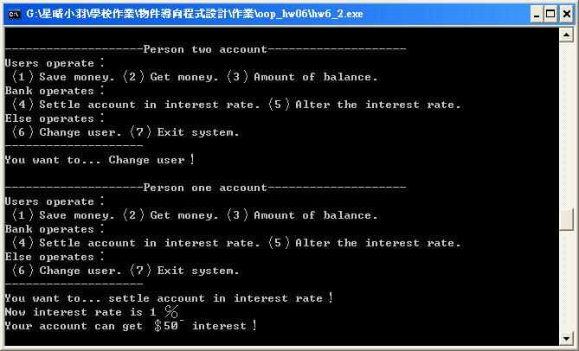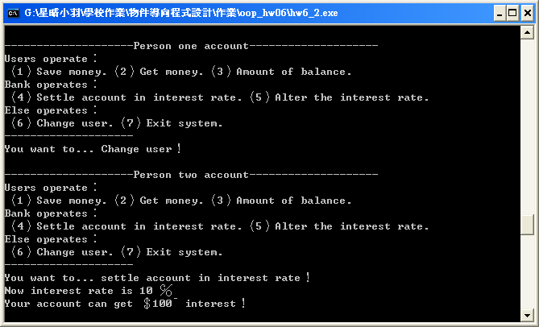

（六） All user can select three to observe balance have already added how much money.
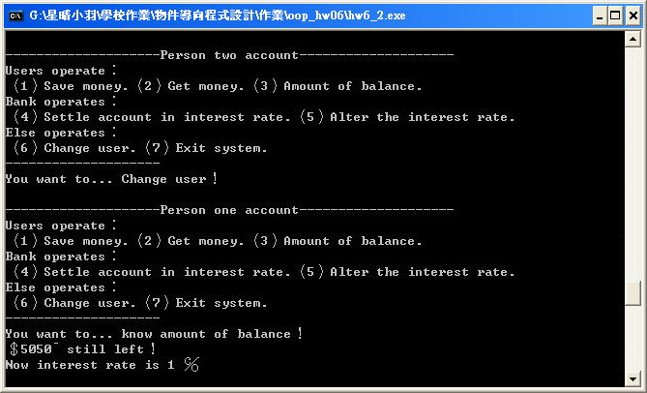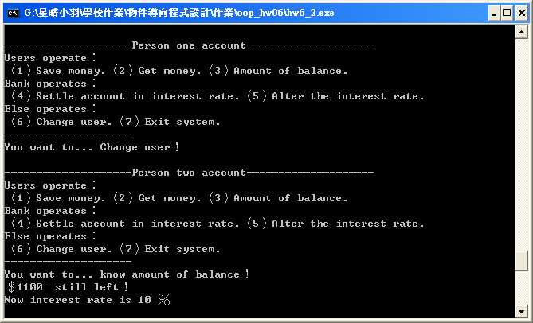

（七） Select two users can get money they have.
First user one gets five thousand dollars.
User two gets six hundred dollars.
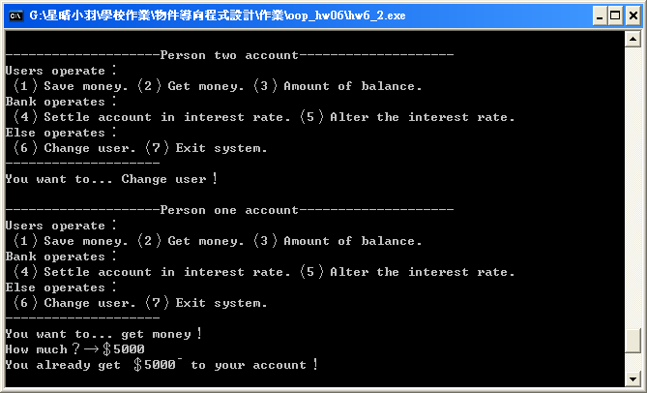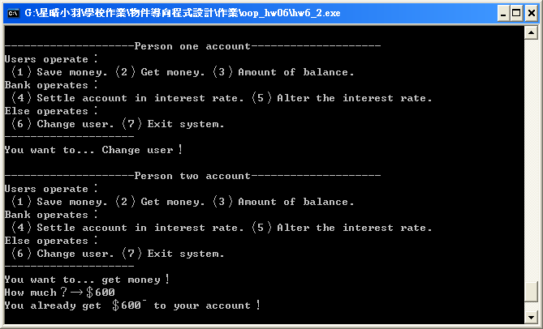

（八） All user can select three to observe their account have already decrease how much money.
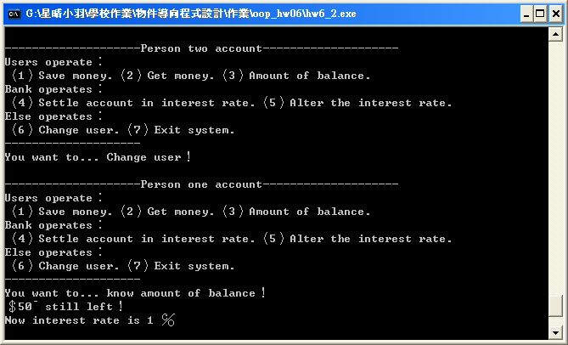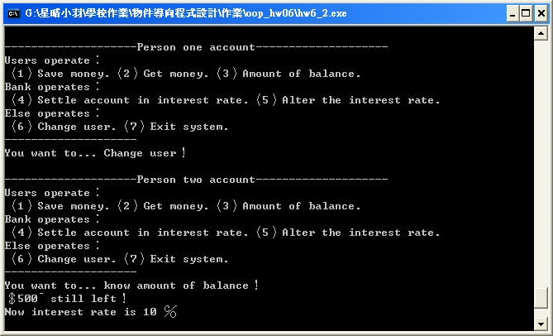

（九） If user one want to get seven thousand dollars, it will appear error!
User two want to get five thousand dollars, it will appear error!
